Use:
Once one copy is purchased a physician or healthcare provider may use these templates freely in their own clinical practice. One copy must be purchased per provider.

This e-book is intended for use by physicians and care providers only.

Notes:
Many of the fields are “pre-filled” based on common answers. You can delete these if you prefer. “Plan” section is based on commonly discussed topics at these well child visits. It is NOT expected that a provider would discuss every topic.

Note that objective exam includes both male and female genital exam findings. Be sure to delete exam findings that are not pertinent.

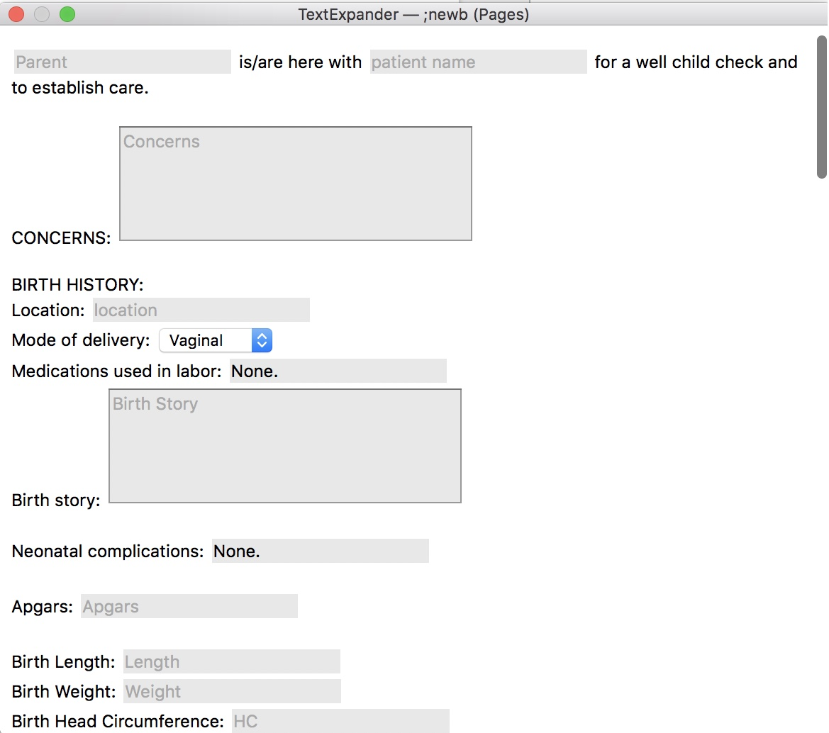
About TextExpander:
Text expander is a paid app that lets you insert snippets of text using short codes. You will need to set up each snippet with a keyword or short code that you prefer. In my practice I use snippets starting with a semi-colon (to prevent from accidental use of a text expander). For example typing ;newb would pull up my entire newborn subjective.

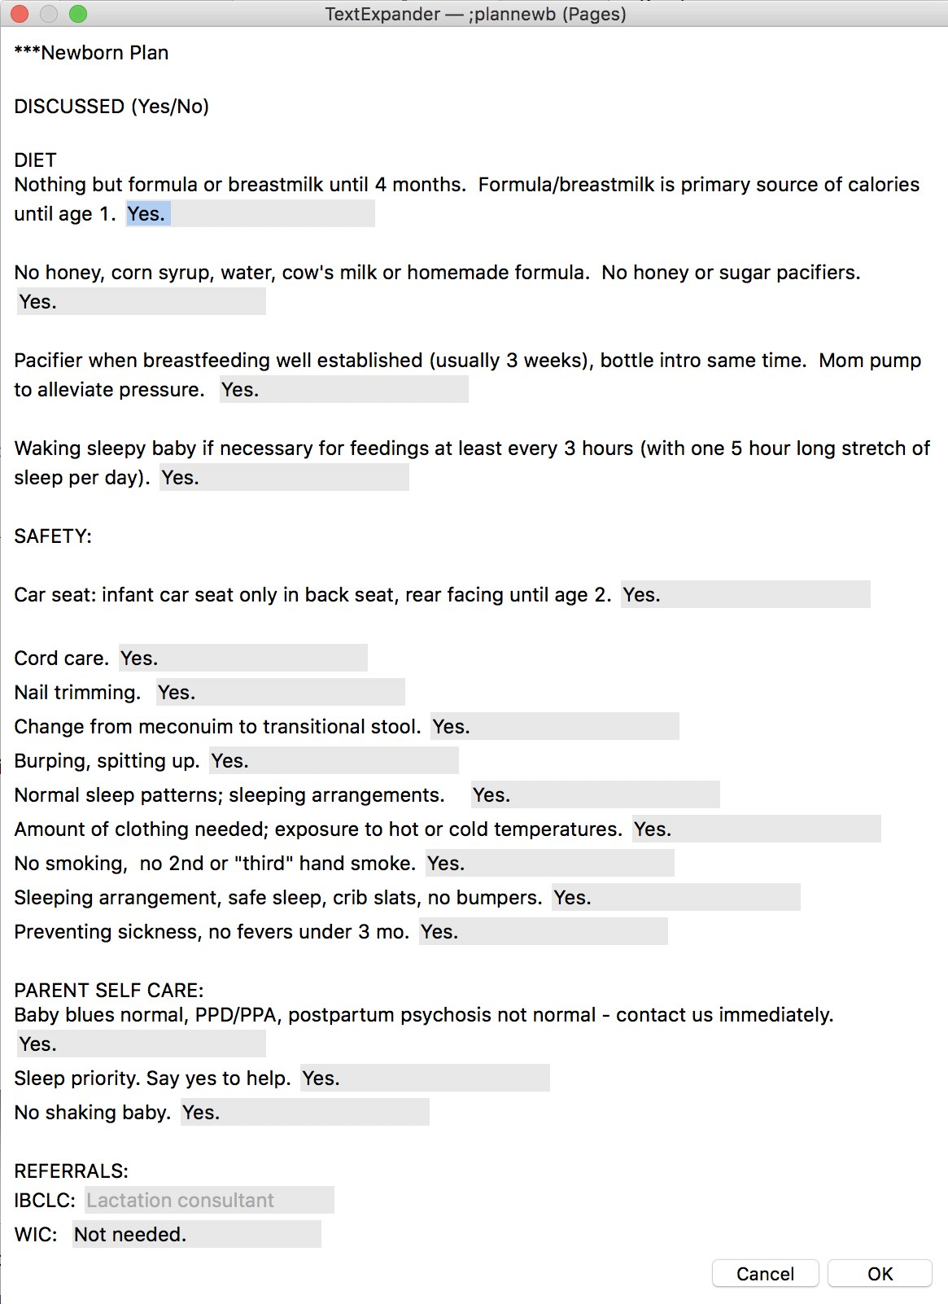
Typing ;plannewb would bring up my entire newborn plan section.

To get TextExpander I recommend NOT purchasing one of their subscriptions, but rather paying up front. You can find their standalone app at: https://textexpander.com/textexpander-standalone-apps/

(I have no affiliation with TexExpander.)

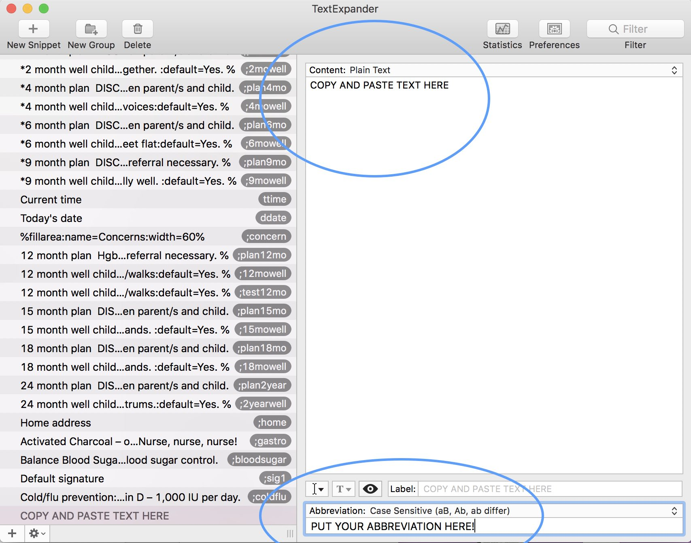
When setting up your snippets select the + icon and press “add new snippet.” Copy and paste ONE section from the text below into the section that says “content.” Put your abbreviation in the bottom. Remember it IS case sensitive.

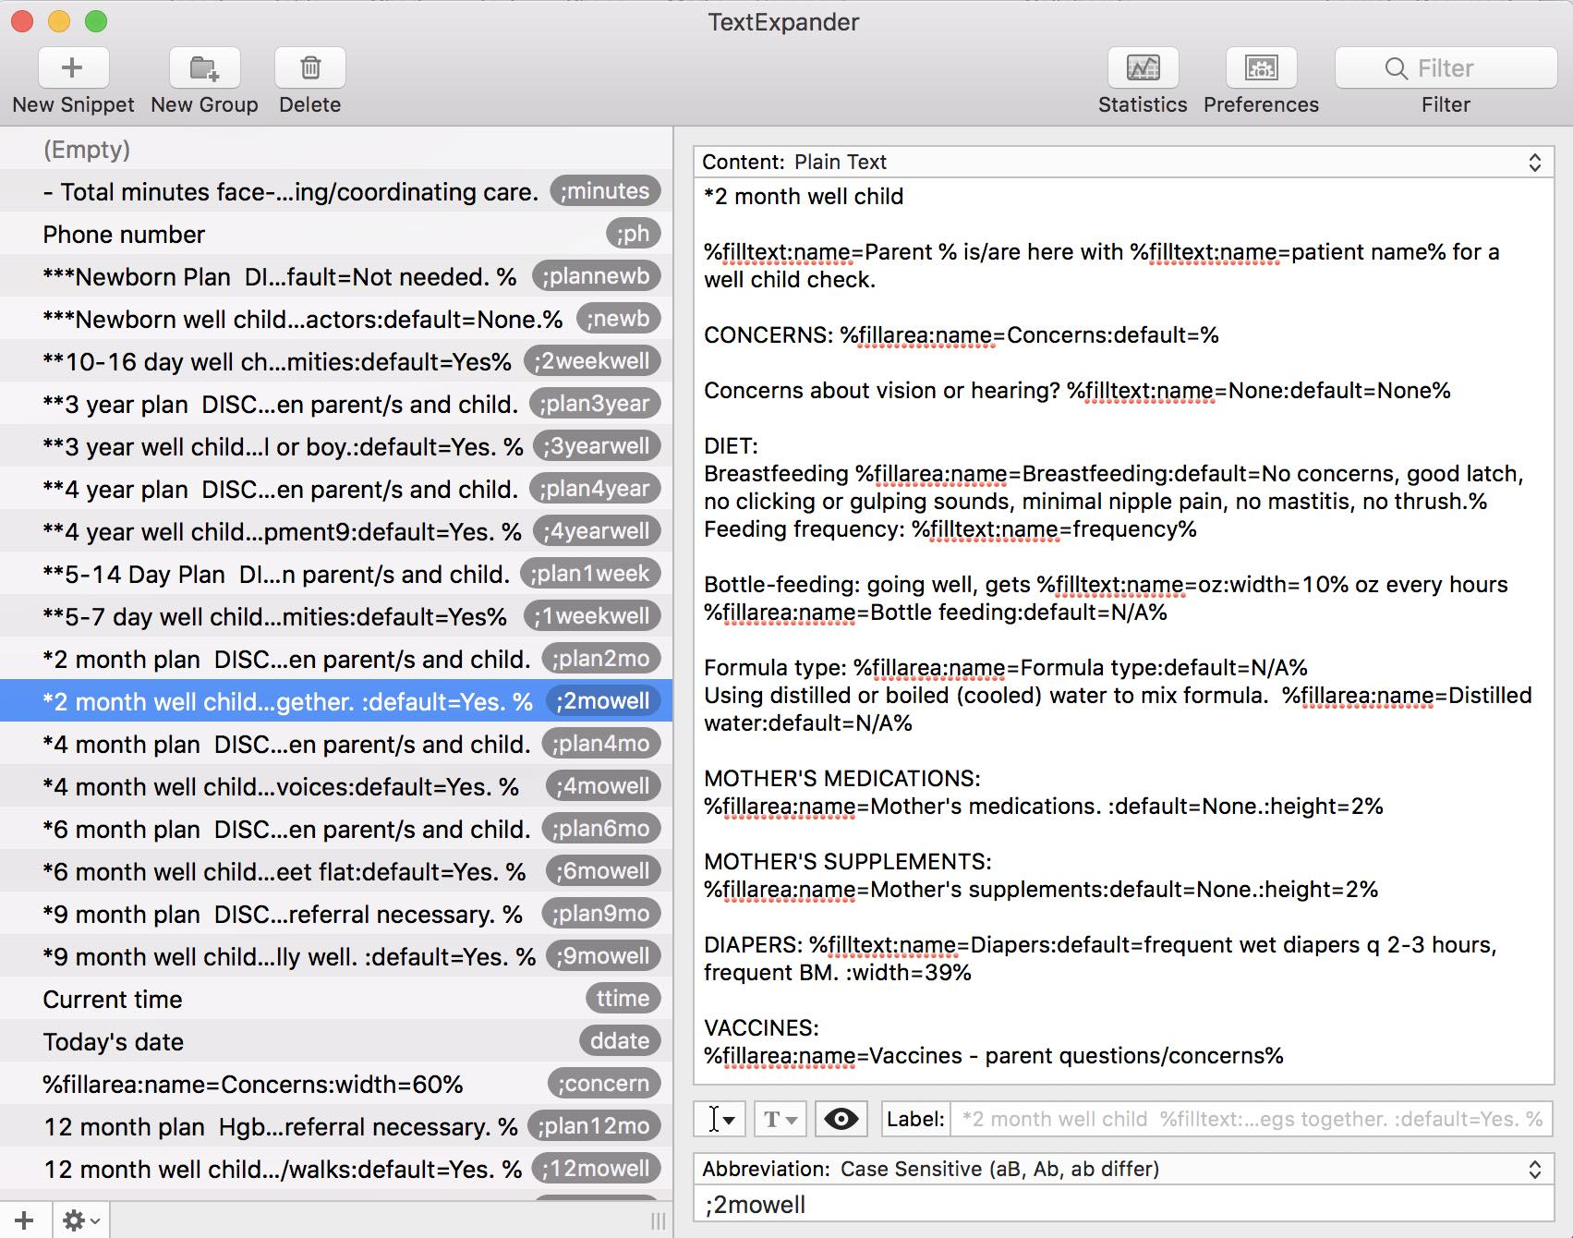
Here’s an example from my own TextExpander:
When using your TextExpander simply type your shortcode into your chart note and the full snippet will appear in a pop-up field as you see in my example above (the first example). Click “okay” and it will appear in your chart note. (Sometimes it takes a few seconds to appear.)

I highly recommend testing it a few times before utilizing it in your office. If you click onto a different screen before selecting “okay” it is possible to lose your notes, so be careful.
Newborn

Subjective:
***Newborn well child

%filltext:name=Parent % is/are here with %filltext:name=patient name% for a well child check and to establish care.

CONCERNS: %fillarea:name=Concerns:default=%

BIRTH HISTORY:
Location: %filltext:name=location%
Mode of delivery: %fillpopup:name=popup 3:Vaginal:Cesarean%
Medications used in labor: %filltext:name=Medications:default=None. %
Birth story: %fillarea:name=Birth Story%

Neonatal complications: %filltext:name=Complications:default=None. %

Apgars: %filltext:name=Apgars%

Birth Length: %filltext:name=Length%
Birth Weight: %filltext:name=Weight%
Birth Head Circumference: %filltext:name=HC%

Newborn procedures:
Hepatitis B - %filltext:name=Hep B:default=Yes%
Erythromycin eye ointment - %filltext:name=Erythro:default=Yes%
IM Vitamin K %filltext:name=Vit K:default=Yes%

Hearing screen: %filltext:name=Hearing:default=Pass.%
Newborn metabolic screening: %filltext:name=Metabolic:default=Completed. %

PRENATAL HISTORY:
- %filltext:name=GBS:default=Negative% GBS
- %filltext:name=Gestational diabetes:default=Negative% Gestational diabetes
- %filltext:name=Weight gain:default=Negative% excessive weight gain
- %filltext:name=Mood disorders:default=Negative% antepartum depression/mood disorders
- %filltext:name=HTN:default=Negative% hypertension

Alcohol use: %filltext:name=EtOH:default=None.%
Recreational drug use including marijuana: %filltext:name=Drug:default=None.%

Smoking (former and current, including cigarettes, cigars, marijuana, vaping): %filltext:name=Smoking:default=None in past, none current. %

Mother's medication use in pregnancy: %filltext:name=Medication:default=No prescription medications. Prenatal vitamins, etc. %

FAMILY HISTORY:
%fillarea:name=Family history%

MEDICATIONS:
%fillarea:name=Infant medications:default=None.:height=2%

SUPPLEMENTS:
%fillarea:name=Infant supplements:default=None.:height=2%

MOTHER'S MEDICATIONS:
%fillarea:name=Mother's medications. :default=None.:height=2%

MOTHER'S SUPPLEMENTS:
%fillarea:name=Mother's supplements:default=None.:height=2%

BREASTFEEDING:
%fillarea:name=Breastfeeding:default=No concerns, good latch, no clicking or gulping sounds, minimal nipple pain, no mastitis, no thrush.%
Feeding frequency: %filltext:name=frequency:default=On demand, every 1-3 hours. %

DIAPERS: %fillarea:name=Diapers:default=Passed meconium within 24 hours.%

CORD: %filltext:name=Cord:default=Good, no concerns, no redness. %

SLEEP:
Sleep position: %filltext:name=Sleep position%
%fillarea:name=Sleep information%

SOCIAL:
Lives with: %filltext:name=Lives with%
Siblings: %filltext:name=Siblings:default=None. %
Pets: %filltext:name=Pets:default=None. %
Other caregivers: %filltext:name=Other caregivers:default=None. %

PARENTS:
Mental health:
%fillarea:name=Mental health:default=Denies seeing or hearing things that are not there (hallucinations), paranoia, suicidal thoughts or actions, disorientation, bizarre behavior, thoughts of harming self or child.%

Parent health/Safety:
%fillarea:name=Parent health/safety:default=Feels safe at home.
No concerns with providing enough food, diapers, clothing, child care. %

Mom diet:
%fillarea:name=Mother's diet:default=
not vegan, well balanced, taking prenatal vitamin. No medications that interfere with breastfeeding. %

RELIGIOUS/SPIRITUAL:
Religious or spiritual factors that may affect healthcare, or provider's ability to provide healthcare? %filltext:name=Religious/spiritual factors:default=None.%

Objective:

GENERAL: well nourished term neonate. Coloration: pink, well perfused.

HEAD: symmetric, no plagiocephaly. Fontanelles soft and flat. Sutures normal. Face: symmetric. No palsies noted..
EYES: symmetric, normal spacing. Sclerae white/clear. No conjunctival hemorrhage. No discharge. Red reflex present and symmetric b/l.
EARS: normal position, size. No No branchial cleft cysts, sinuses, preauricular skin tags or pits.
NOSE: nares patent.
MOUTH: symmetric, no micrognathia. No ankyloglossia. Buccal mucosa normal. Palate intact.
NECK: normal, no masses, no torticollis. Clavicles intact.
CHEST: symmetric, no abnormalities..
LUNGS: no rapid breathing, nasal flaring, use of accessory muscles. Lung fields CTA.
CARDIAC: pulse oximetry > 95% R hand, R foot. Femoral pulses symmetric. RRR, no murmurs.
ABDOMEN: no masses. No hepatosplenomegaly. Umbilical cord stump normal, no sign of infection.
GENITALIA: Female: no labial adhesion, vaginal opening patent. Male: uncircumcised penis, urethral meatus appropriately positioned. Testes down.
MUSCULOSKELETAL: normal tone, no head lag.
NEURO: Moro reflex present, plantar grasp reflex present, palmar grasp reflex present.

Assessment:

Z00.110 Health examination for newborn under 8 days old

Plan:

***Newborn Plan

DISCUSSED (Yes/No)

DIET
Nothing but formula or breastmilk until 4 months. Formula/breastmilk is primary source of calories until age 1. %filltext:name=Diet:default=Yes. %

No honey, corn syrup, water, cow's milk or homemade formula. No honey or sugar pacifiers. %filltext:name=No Honey:default=Yes. %

Pacifier when breastfeeding well established (usually 3 weeks), bottle intro same time. Mom pump to alleviate pressure. %filltext:name=Pacifier:default=Yes. %

Waking sleepy baby if necessary for feedings at least every 3 hours (with one 5 hour long stretch of sleep per day). %filltext:name=Sleepy baby:default=Yes. %

SAFETY:

Car seat: infant car seat only in back seat, rear facing until age 2. %filltext:name=Car seat:default=Yes. %

Cord care. %filltext:name=Cord care:default=Yes. %
Nail trimming. %filltext:name=Nail trimming:default=Yes. %
Change from meconuim to transitional stool. %filltext:name=Transitional stool:default=Yes. %
Burping, spitting up. %filltext:name=Burping.:default=Yes. %
Normal sleep patterns; sleeping arrangements. %filltext:name=Sleep patterns:default=Yes. %
Amount of clothing needed; exposure to hot or cold temperatures. %filltext:name=Clothing needed:default=Yes. %
No smoking, no 2nd or "third" hand smoke. %filltext:name=Smoke:default=Yes. %
Sleeping arrangement, safe sleep, crib slats, no bumpers. %filltext:name=Safe sleep:default=Yes. %
Preventing sickness, no fevers under 3 mo. %filltext:name=No fevers:default=Yes. %

PARENT SELF CARE:
Baby blues normal, PPD/PPA, postpartum psychosis not normal - contact us immediately. %filltext:name=PPD/PPA:default=Yes. %
Sleep priority. Say yes to help. %filltext:name=Sleep:default=Yes. %
No shaking baby. %filltext:name=Shaking baby:default=Yes. %

REFERRALS:
IBCLC: %filltext:name=Lactation consultant%
WIC: %filltext:name=WIC:default=Not needed. %

1 week well child

Subjective
**5-7 day well child exam

%filltext:name=Parent % is/are here with %filltext:name=patient name% for a well child check.

CONCERNS: %fillarea:name=Concerns:default=%

FAMILY HISTORY:
%fillarea:name=Family history:default=Reviewed-no changes. %

PERSONAL MEDICAL HISTORY:
%fillarea:name=PMHx:default=No major changes. NKDA. %

MEDICATIONS:
%fillarea:name=Infant medications:default=None.:height=2%

SUPPLEMENTS:
%fillarea:name=Infant supplements:default=None.:height=2%

MOTHER'S MEDICATIONS:
%fillarea:name=Mother's medications. :default=None.:height=2%

MOTHER'S SUPPLEMENTS:
%fillarea:name=Mother's supplements:default=None.:height=2%

BREASTFEEDING:
%fillarea:name=Breastfeeding:default=No concerns, good latch, no clicking or gulping sounds, minimal nipple pain, no mastitis, no thrush.%
Feeding frequency: %filltext:name=frequency:default=On demand, every 1-3 hours. %

DIAPERS: %fillarea:name=Diapers:default=Good. Wet diapers q 1-3 hours, stools 4+ daily. Mustard colored stools. %

CORD: %filltext:name=Cord:default=Good, no concerns, no redness. %

SLEEP:
Sleep position: %filltext:name=Sleep position%
%fillarea:name=Sleep information%

SOCIAL:
Lives with: %filltext:name=Lives with%
Siblings: %filltext:name=Siblings:default=Transitioning well. No concerns. %

SAFETY:
Smoke detector/carbon monoxide detector in home. %filltext:name=Smoke detector:default=Yes%

Diffused essential oils, scented home products: %filltext:name=Environmental exposure:default=None.%

PARENTS:
Mental health:
%fillarea:name=Mental health:default=Denies seeing or hearing things that are not there (hallucinations), paranoia, suicidal thoughts or actions, disorientation, bizarre behavior, thoughts of harming self or child.%

Mom diet:
%fillarea:name=Mother's diet:default=No changes. %

VACCINES:
%fillarea:name=Vaccines - questions/concerns of parents. %

DEVELOPMENT:
Responds to sounds. %filltext:name=Sounds:default=Yes%
Makes eye contact. %filltext:name=Eye contact:default=Yes%
Responds to parent's face. %filltext:name=Parents face:default=Yes%
Moves all extremities.%filltext:name=extremities:default=Yes%

Objective:

GENERAL: well nourished term neonate. Coloration: pink, well perfused.
HEAD: symmetric, no plagiocephaly. Fontanelles soft and flat. Sutures normal. Face: symmetric. No palsies noted..
EYES: symmetric, normal spacing. Sclerae white/clear. No conjunctival hemorrhage. No discharge. Red reflex present and symmetric b/l.
EARS: normal position, size. No No branchial cleft cysts, sinuses, preauricular skin tags or pits.
NOSE: nares patent.
MOUTH: symmetric, no micrognathia. No ankyloglossia. Buccal mucosa normal. Palate intact.
NECK: normal, no masses, no torticollis. Clavicles intact.
CHEST: symmetric, no abnormalities..
LUNGS: no rapid breathing, nasal flaring, use of accessory muscles. Lung fields CTA.
CARDIAC: pulse oximetry > 95% R hand, R foot. Femoral pulses symmetric. RRR, no murmurs.
ABDOMEN: no masses. No hepatosplenomegaly. Umbilical cord stump normal, no sign of infection.
GENITALIA: Female: no labial adhesion, vaginal opening patent. Male: uncircumcised penis, urethral meatus appropriately positioned. Testes down.
MUSCULOSKELETAL: normal tone, no head lag.
NEURO: Moro reflex present, plantar grasp reflex present, palmar grasp reflex present.

Assessment:

Z00.110 Health examination for newborn under 8 days old

Z00.111 Health examination for newborn 8 to 28 days old

Plan:
**5-14 Day Plan

DISCUSSED (Yes/No)

DIET:
Reviewed signs of hunger: hand to mouth, sucking, fussing, rooting. End feeding when baby turns away, closes mouth, relaxes hands. %filltext:name=Hunger signs:default=Yes. %

Pacifier when breastfeeding well established (usually 3 weeks), bottle intro same time. %filltext:name=Pacifier:default=Yes. %

SAFETY:
- Reviewed: Normal sleep patterns, change of circadian rhythm, safe sleep. %filltext:name=Sleep patterns:default=Yes. %

- Amount of clothing needed; exposure to hot or cold temperatures. %filltext:name=Clothing needed:default=Yes. %

- Crying, colic. %filltext:name=Colic:default=Yes. %

- Reviewed: No fevers under 3 mo. How to use temporal artery or rectal thermometer. Have everyone wash hands before touching baby. Avoid public spaces during cold/flu season. Keep baby in baby carrier or covered car seat in public spaces. %filltext:name=No fevers:default=Yes. %

- Do not smoke (cigarette, marijuana, vaping). Also avoid essential oil diffusers (too strong for infants), scented home products (plug-ins, etc). %filltext:name=Environmental exposures:default=Yes%

DEVELOPMENT:
- Start tummy time, 5-15 minutes on floor or on parent's chest. %filltext:name=Tummy time:default=Yes%
- Talk to your baby. %filltext:name=Talk:default=Yes%
- 1 on 1 time with sibling. %filltext:name=1 on 1 time:default=Yes%

PARENT SELF CARE:
Reviewed: Baby blues normal, PPD/PPA, postpartum psychosis not normal - contact us immediately. %filltext:name=PPD/PPA:default=Yes. %
Sleep priority. Say yes to help. %filltext:name=Sleep:default=Yes. %
Reviewed: Frustration is normal; do not shake your baby. %filltext:name=Shaking baby:default=Yes. %
Use contraception immediately (if not religiously opposed to contraception), breastfeeding is not always a reliable contraception method. %filltext:name=Contraception:default=Yes. %
Receiving unwanted advice - smile, say thanks, change the subject. %filltext:name=Unwanted advice:default=Yes. %

PROMOTING FIRST RELATIONSHIPS:
Observed & encouraged connection between parent/s and child.

2 week well child

Subjective:
**10-16 day well child exam

%filltext:name=Parent % is/are here with %filltext:name=patient name% for a well child check.

CONCERNS: %fillarea:name=Concerns:default=%

FAMILY HISTORY:
%fillarea:name=Family history:default=Reviewed-no changes. %

PERSONAL MEDICAL HISTORY:
%fillarea:name=PMHx:default=No major changes. NKDA. %

MEDICATIONS:
%fillarea:name=Infant medications:default=None.:height=2%

SUPPLEMENTS:
%fillarea:name=Infant supplements:default=None.:height=2%

MOTHER'S MEDICATIONS:
%fillarea:name=Mother's medications. :default=None.:height=2%

MOTHER'S SUPPLEMENTS:
%fillarea:name=Mother's supplements:default=None.:height=2%

BREASTFEEDING:
%fillarea:name=Breastfeeding:default=No concerns, good latch, no clicking or gulping sounds, minimal nipple pain, no mastitis, no thrush.%
Feeding frequency: %filltext:name=frequency:default=On demand, every 1-3 hours. %

DIAPERS: %fillarea:name=Diapers:default=Good. Wet diapers q 1-3 hours, stools 4+ daily. Mustard colored stools. %

SLEEP:
Sleep position: %filltext:name=Sleep position%
%fillarea:name=Sleep information%

SOCIAL:
Lives with: %filltext:name=Lives with:default=No changes. %
Siblings: %filltext:name=Siblings:default=Transitioning well. No concerns. %

SAFETY:
Smoke detector/carbon monoxide detector in home. %filltext:name=Smoke detector:default=Yes%

Checked hot water heater (120 degrees or less). %filltext:name=Hot water:default=Yes%

PARENTS:
Mental health:
%fillarea:name=Mental health:default=Denies seeing or hearing things that are not there (hallucinations), paranoia, suicidal thoughts or actions, disorientation, bizarre behavior, thoughts of harming self or child.%

Mom diet:
%fillarea:name=Mother's diet:default=No changes. %

Return to work? %filltext:name=Return to work%

DEVELOPMENT:
Responds to sounds. %filltext:name=Sounds:default=Yes%
Makes eye contact. %filltext:name=Eye contact:default=Yes%
Responds to parent's face. %filltext:name=Parents face:default=Yes%
Moves all extremities.%filltext:name=extremities:default=Yes%

Objective:

GENERAL: well appearing infant. Coloration: pink, well perfused.
HEAD: symmetric, no plagiocephaly. Fontanelles soft and flat. Sutures normal. Face: symmetric. No palsies noted..
EYES: symmetric, normal spacing. Sclerae white/clear. No conjunctival hemorrhage. No discharge. Red reflex present and symmetric b/l.
EARS: normal position, size. No No branchial cleft cysts, sinuses, preauricular skin tags or pits.
NOSE: nares patent.
MOUTH: symmetric, no micrognathia. No ankyloglossia. Buccal mucosa normal. Palate intact.
NECK: normal, no masses, no torticollis. Clavicles intact.
CHEST: symmetric, no abnormalities..
LUNGS: no rapid breathing, nasal flaring, use of accessory muscles. Lung fields CTA.
CARDIAC: pulse oximetry > 95% R hand, R foot. Femoral pulses symmetric. RRR, no murmurs.
ABDOMEN: no masses. No hepatosplenomegaly. Umbilical cord stump normal, no sign of infection.
GENITALIA: Female: no labial adhesion, vaginal opening patent. Male: uncircumcised penis, urethral meatus appropriately positioned. Testes down.
MUSCULOSKELETAL: normal tone, no head lag.
NEURO: Moro reflex present, plantar grasp reflex present, palmar grasp reflex present.

Assessment:

Z00.111 Health examination for newborn 8 to 28 days old

Plan:
(same as 1 week plan, review points not covered last visit)

%filltext:name=Parent % is/are here with %filltext:name=patient name% for a well child check.

CONCERNS: %fillarea:name=Concerns:default=%

FAMILY HISTORY:
%fillarea:name=Family history:default=Reviewed-no changes. %

PERSONAL MEDICAL HISTORY:
%fillarea:name=PMHx:default=No major changes. NKDA. %

MEDICATIONS:
%fillarea:name=Infant medications:default=None.:height=2%

SUPPLEMENTS:
%fillarea:name=Infant supplements:default=None.:height=2%

MOTHER'S MEDICATIONS:
%fillarea:name=Mother's medications. :default=None.:height=2%

MOTHER'S SUPPLEMENTS:
%fillarea:name=Mother's supplements:default=None.:height=2%

BREASTFEEDING:
%fillarea:name=Breastfeeding:default=No concerns, good latch, no clicking or gulping sounds, minimal nipple pain, no mastitis, no thrush.%
Feeding frequency: %filltext:name=frequency:default=On demand, every 1-3 hours. %

DIAPERS: %fillarea:name=Diapers:default=Good. Wet diapers q 1-3 hours, stools 4+ daily. Mustard colored stools. %

SLEEP:
Sleep position: %filltext:name=Sleep position%
%fillarea:name=Sleep information%

SOCIAL:
Lives with: %filltext:name=Lives with:default=No changes. %
Siblings: %filltext:name=Siblings:default=Transitioning well. No concerns. %

SAFETY:
Smoke detector/carbon monoxide detector in home. %filltext:name=Smoke detector:default=Yes%

Checked hot water heater (120 degrees or less). %filltext:name=Hot water:default=Yes%

PARENTS:
Mental health:
%fillarea:name=Mental health:default=Denies seeing or hearing things that are not there (hallucinations), paranoia, suicidal thoughts or actions, disorientation, bizarre behavior, thoughts of harming self or child.%

Mom diet:
%fillarea:name=Mother's diet:default=No changes. %

Return to work? %filltext:name=Return to work%

DEVELOPMENT:
Responds to sounds. %filltext:name=Sounds:default=Yes%
Makes eye contact. %filltext:name=Eye contact:default=Yes%
Responds to parent's face. %filltext:name=Parents face:default=Yes%
Moves all extremities.%filltext:name=extremities:default=Yes%

2 month well child

Subjective:
*2 month well child

%filltext:name=Parent % is/are here with %filltext:name=patient name% for a well child check.

CONCERNS: %fillarea:name=Concerns:default=%

Concerns about vision or hearing? %filltext:name=None:default=None%

FAMILY HISTORY:
%fillarea:name=Family history:default=Reviewed-no changes. %

PERSONAL MEDICAL HISTORY:
%fillarea:name=PMHx:default=No major changes. NKDA. %

MEDICATIONS:
%fillarea:name=Infant medications:default=None.:height=2%

SUPPLEMENTS:
%fillarea:name=Infant supplements:default=None.:height=2%

MOTHER'S MEDICATIONS:
%fillarea:name=Mother's medications. :default=None.:height=2%

MOTHER'S SUPPLEMENTS:
%fillarea:name=Mother's supplements:default=None.:height=2%

DIET:
Breastfeeding %fillarea:name=Breastfeeding:default=No concerns, good latch, no clicking or gulping sounds, minimal nipple pain, no mastitis, no thrush.%
Feeding frequency: %filltext:name=frequency%

Bottle-feeding: going well, gets %filltext:name=oz:width=10% oz every hours
%fillarea:name=Bottle feeding:default=N/A%

Formula type: %fillarea:name=Formula type:default=N/A%
Using distilled or boiled (cooled) water to mix formula. %fillarea:name=Distilled water:default=N/A%

DIAPERS: %filltext:name=Diapers:default=frequent wet diapers q 2-3 hours, frequent BM. :width=39%

VACCINES:
%fillarea:name=Vaccines - parent questions/concerns%

SLEEP:
Sleep position: %filltext:name=Sleep position%
%fillarea:name=Sleep information%

SOCIAL:
Major changes in the family: %filltext:name=Major changes:default=There are no major changes in the family (divorce, separation, new job, new home). :width=70%
New caregivers? %filltext:name=Caregivers:default=None. %
Returning to work: %filltext:name=Return to work%
Support system: %filltext:name=Support system%

Parent's mood: %filltext:name=Mood:default=Good. No concerns. %

SAFETY:
Has smoke & carbon monoxide detectors in the home. %filltext:name=Smoke detectors:default=Yes. %

PROMOTING FIRST RELATIONSHIPS:
(Open-ended) What is your child like? What is it like to parent your baby? %fillarea:name=PFR%

DEVELOPMENT:
- Smiles. %filltext:name=Smiles:default=Yes. %
- Coos. %filltext:name=Coos:default=Yes. %
- Looks at caregiver. %filltext:name=Eye contact:default=Yes. %
- Comforts self (brings hands to mouth). %filltext:name=Comforts self:default=Yes. %
- Holds head up in prone position. %filltext:name=Holds head in prone:default=Yes. %
- Moves both arms and legs together . %filltext:name=Moves arms/legs together. :default=Yes. %

Objective:
GENERAL: well appearing infant in NAD. No abuse or neglect evident. Good attachment to parent.

HEAD: normocephalic, atraumatic. Anterior fontanelle open and flat.

SKIN: clear, no rashes or lesions evident.

EYES: conjunctivae and sclera clear, red reflex present and symmetric bilaterally.

EARS: canals mostly clear, TM not visualized due to size.

NOSE: nares appear patent, clear.

MOUTH: No lip or tongue tie. No visible teeth.

NECK: Supple, no masses, no thyromegaly.

LUNGS: Respiration even and unlabored. No ICS retraction or unilateral lag. No contraction of SCM or scalenes noted. Lung fields clear to auscultation.

HEART: RRR, no murmurs, clicks, rubs, snaps or extra sounds. S1 and S2 not diminished, exaggerated or abnormally split. Femoral pulses normal.

ABDOMEN: Soft, no masses, no tenderness, no organomegaly.

HIPS: Good abduction, no hip click noted.

GENITALIA, ANUS: Grossly normal, normal development. No diaper dermatitis.
%fillarea:name=Genitalia:default=Male- uncircumcised penis, testes down.
Female- normal, no labial adhesion. %

Assessment:
Z00.121 Encounter for routine child health examination with abnormal findings Z00.129 Encounter for routine child health examination without abnormal findings

Plan:
*2 month plan

DISCUSSED: (Yes/No)

2 mo babies cannot be "spoiled." (First 3 months of life are considered "4th trimester.") Babies are reliant upon caregivers to get all needs met. Cuddle, talk, read, sing, wear your babies. Eye contact with parents literally lays down neuronal connections. %filltext:name=Babies cannot be spoiled:default=Yes%

Recommend beginning 400-800 iu vitamin D daily. %filltext:name=Vit D:default=Yes%
No propping bottle. %filltext:name=Bottle:default=Yes%

Colic – normal periods of unexplained crying. %filltext:name=Colic:default=Yes%

Mother's health - moderate exercise, not dieting but eating healthy. Continuing to take prenatal vitamin. Recommend fish oil to supplement lost fatty acids. %filltext:name=Mother's health:default=Yes%
Resuming sexual intercourse. %filltext:name=Resuming intercourse:default=Yes%
Parent mood, normal fatigue, hormonal changes, recognizing postpartum depression. %filltext:name=PPD/PPA:default=Yes%

Social support – say yes to help, join parenting groups. %filltext:name=Social support:default=Yes%

Safety: Keeping hand on baby while on changing table. Never leave baby alone in sink or bathtub even for a few seconds. Do not shake your baby. %filltext:name=Safety:default=Yes%

Baby carrier safety: do not recommend Baby Bjorn or other carrier that does not support hips. Limit forward-facing to 15 minutes. %filltext:name=Baby carrier:default=Yes%

ANTICIPATORY GUIDANCE:
Gave Naturopathic Pediatrics 2 month well child handout.

VACCINATIONS:
Vaccines: Discussed ACIP recommended vaccines x %filltext:name=vaccines% minutes.

Parents choose: %fillarea:name=Vaccines parents choose%

PROMOTING FIRST RELATIONSHIPS:
Observed & encouraged connection between parent/s and child.

4 month well child

Subjective:
*4 month well child

%filltext:name=Parent % is/are here with %filltext:name=patient name% for a well child check.

CONCERNS: %fillarea:name=Concerns:default=%

Concerns about vision or hearing? %filltext:name=None:default=None%

FAMILY HISTORY:
%fillarea:name=Family history:default=Reviewed-no changes. %

PERSONAL MEDICAL HISTORY:
%fillarea:name=PMHx:default=No major changes. NKDA. %

MEDICATIONS:
%fillarea:name=Infant medications:default=None.:height=2%

SUPPLEMENTS:
%fillarea:name=Infant supplements:default=None.:height=2%

MOTHER'S MEDICATIONS:
%fillarea:name=Mother's medications. :default=None.:height=2%

MOTHER'S SUPPLEMENTS:
%fillarea:name=Mother's supplements:default=None.:height=2%

DIET:
Breastfeeding %fillarea:name=Breastfeeding:default=No concerns, good latch, no clicking or gulping sounds, minimal nipple pain, no mastitis, no thrush.%
Feeding frequency: %filltext:name=frequency%

Bottle-feeding: going well, gets %filltext:name=oz:width=10% oz every hours
%fillarea:name=Bottle feeding:default=N/A%

Formula type: %fillarea:name=Formula type:default=N/A%
Using distilled or boiled (cooled) water to mix formula. %fillarea:name=Distilled water:default=N/A%

DIAPERS: %filltext:name=Diapers:default=frequent wet diapers q 2-3 hours, frequent BM. :width=39%

VACCINES:
%fillarea:name=Vaccines - parent questions/concerns%
Infant tolerated 2 month vaccinations? %filltext:name=Vaccinations:default=Yes. No concerns. %

SLEEP:
Sleep position: %filltext:name=Sleep position%
%fillarea:name=Sleep information%

SOCIAL:
Major changes in the family: %filltext:name=Major changes:default=There are no major changes in the family (divorce, separation, new job, new home). :width=70%
New caregivers? %filltext:name=Caregivers:default=None. %

Parent's mood: %filltext:name=Mood:default=Good. No concerns. %

PROMOTING FIRST RELATIONSHIPS:
(Open-ended) What is your child like? What is it like to parent your baby? %fillarea:name=PFR%

DEVELOPMENT:
- Smiles. %filltext:name=Smiles:default=Yes. %
- Laughs (or chuckles softly). %filltext:name=Laughs:default=Yes. %
- Moves head side to side while supine. %filltext:name=moves head:default=Yes. %
- Holds head up while prone, head doesn't drop down. %filltext:name=Holds head up:default=Yes. %
- Lifts chest (occasional). %filltext:name=Lifts chest:default=Yes. %
- Steady head control. %filltext:name=Head control:default=Yes. %
- Brings hands together. %filltext:name=Hands together:default=Yes. %
- Holds toy briefly. %filltext:name=Holds toy briefly:default=Yes. %
- Grabs clothes (own, or mom's while nursing). %filltext:name=Grabs clothes:default=Yes. %
- Eyes track face or object. %filltext:name=Eyes track object:default=Yes. %
- Babbles. %filltext:name=Babbles:default=Yes. %
- Orients to voices. %filltext:name=Orients to voices:default=Yes. %

Objective:
GENERAL: well appearing infant in NAD. No abuse or neglect evident. Good attachment to parent.

HEAD: normocephalic, atraumatic. Anterior fontanelle open and flat.

SKIN: clear, no rashes or lesions evident.

EYES: conjunctivae and sclera clear, red reflex present and symmetric bilaterally.

EARS: canals mostly clear, TM not visualized due to size.

NOSE: nares appear patent, clear.

MOUTH: No lip or tongue tie. No visible teeth.

NECK: Supple, no masses, no thyromegaly.

LUNGS: Respiration even and unlabored. No ICS retraction or unilateral lag. No contraction of SCM or scalenes noted. Lung fields clear to auscultation.

HEART: RRR, no murmurs, clicks, rubs, snaps or extra sounds. S1 and S2 not diminished, exaggerated or abnormally split. Femoral pulses normal.

ABDOMEN: Soft, no masses, no tenderness, no organomegaly.

HIPS: Good abduction, no hip click noted.

GENITALIA, ANUS: Grossly normal, normal development. No diaper dermatitis.
%fillarea:name=Genitalia:default=Male- uncircumcised penis, testes down.
Female- normal, no labial adhesion. %

Assessment:
Z00.121 Encounter for routine child health examination with abnormal findings Z00.129 Encounter for routine child health examination without abnormal findings

Plan:
*4 month plan

DISCUSSED: (Yes/No)

- Normal development. %filltext:name=Development:default=Yes%

- Nursing - normal for breasts to be less engorged. %filltext:name=Engorged:default=Yes%

- Food introductions: recommend "tastes" of solid food between ages of 4-6 months to reduce incidence of food allergies (new research supports earlier solid introductions). No jar-sized portions until 6 months. Introduce all potentially allergenic foods in small quantities, including peanut butter. %filltext:name=Complementary foods:default=Yes%

- Teething tips. Drooling is normal, does not necessarily indicate presence of teeth. No topical essential oils or numbing agents. Lemon balm tea popsicles, etc. Recommend avoiding acetaminophen. %filltext:name=Teething:default=Yes%

- 4 month sleep regression. %filltext:name=Sleep regression:default=Yes%

- Safety: sun (no sunscreen until 6 mo, avoid exposure). Avoid infant walkers/jumpers. %filltext:name=Sun safety:default=Yes%

- Do not shake your baby. %filltext:name=Frustration:default=Yes%

- First fevers. %filltext:name=First fevers:default=Yes%

- Parent's mood. Edinburgh Postnatal Depression Scale given. Score = %filltext:name=Edinburgh%

HANDOUTS:
Gave Naturopathic Pediatrics 4 month well child guide.

VACCINATIONS:
Discussed ACIP recommended 4 mo vaccines. Vaccines today: %fillarea:name=Vaccinations%

PROMOTING FIRST RELATIONSHIPS:
Observed & encouraged connection between parent/s and child.
6 month well child

Subjective:
*6 month well child

%filltext:name=Parent % is/are here with %filltext:name=patient name% for a well child check.

CONCERNS: %fillarea:name=Concerns:default=%

Concerns about vision or hearing? %filltext:name=None:default=None%

FAMILY HISTORY:
%fillarea:name=Family history:default=Reviewed-no changes. %

PERSONAL MEDICAL HISTORY:
%fillarea:name=PMHx:default=No major changes. NKDA. %

MEDICATIONS:
%fillarea:name=Infant medications:default=None.:height=2%

SUPPLEMENTS:
%fillarea:name=Infant supplements:default=None.:height=2%

MOTHER'S MEDICATIONS:
%fillarea:name=Mother's medications. :default=None.:height=2%

MOTHER'S SUPPLEMENTS:
%fillarea:name=Mother's supplements:default=None.:height=2%

DIET:
Solid foods: %fillarea:name=Solid food introductions%

Breastfeeding %fillarea:name=Breastfeeding:default=Is continuing breastfeeding. No concerns.%
Feeding frequency: %filltext:name=frequency%

Bottle-feeding: going well, gets %filltext:name=oz:width=10% oz every hours
%fillarea:name=Bottle feeding:default=N/A%

Formula type: %fillarea:name=Formula type:default=N/A%
Using distilled or boiled (cooled) water to mix formula. %fillarea:name=Distilled water:default=N/A%

Sleeping with a bottle? %filltext:name=Sleep with bottle:default=No. %

DIAPERS: %filltext:name=Diapers:default=frequent wet diapers q 2-3 hours, frequent BM. :width=39%

VACCINES:
%fillarea:name=Vaccines - parent questions/concerns%
Infant tolerated 4 month vaccinations? %filltext:name=Vaccinations:default=Yes. No concerns. %

SLEEP:
Sleep position: %filltext:name=Sleep position%
%fillarea:name=Sleep information%

SOCIAL:
Major changes in the family: %filltext:name=Major changes:default=There are no major changes in the family (divorce, separation, new job, new home). :width=70%
New caregivers? %filltext:name=Caregivers:default=None. %

Parent's mood: %filltext:name=Mood:default=Good. No concerns. %

PROMOTING FIRST RELATIONSHIPS:
(Open-ended) What is your child like? What is it like to parent your baby? %fillarea:name=PFR%

DEVELOPMENT:
- Rolls over. %filltext:name=Rolls:default=Yes. %
- sits briefly. %filltext:name=Sits:default=Yes. %
- babbles. %filltext:name=Babbles:default=Yes. %
- social smiles. %filltext:name=Social smiles:default=Yes. %
- brings objects to mouth. %filltext:name=Brings objects to mouth:default=Yes. %
- Looks in direction of parent's voice when they call. Turns to see where sound is coming from. %filltext:name=Looks to voices:default=Yes. %
- Makes consonant sounds (ga, da or ba). %filltext:name=Consonant sounds:default=Yes. %
- Lifts legs high while on back. %filltext:name=Lifts legs:default=Yes. %
- Pushes chest off the floor. %filltext:name=Pushes chest:default=Yes. %
- Reaches for small objects, attempts raking grasp. %filltext:name=Reaches for small objects:default=Yes. %
- Tries to get a dropped toy. %filltext:name=Gets dropped toy:default=Yes. %
- Smiles at self in mirror (optional: reaches for self in mirror). %filltext:name=Smiles at self:default=Yes. %
- Feet are flat when holding baby to stand.. %filltext:name=Feet flat:default=Yes. %

Objective:
GENERAL: well appearing infant in NAD. No abuse or neglect evident. Good attachment to parent.

HEAD: normocephalic, atraumatic. Anterior fontanelle open and flat.

SKIN: clear, no rashes or lesions evident.

EYES: conjunctivae and sclera clear, red reflex present and symmetric bilaterally.

EARS: canals clear, TM visualized intact no abnormalities.

NOSE: no abnormalities, no discharge.

MOUTH: No lip or tongue tie. Teeth: %filltext:name=Teeth:default=None.%

NECK: Supple, no masses, no thyromegaly.

LUNGS: Respiration even and unlabored. No ICS retraction or unilateral lag. No contraction of SCM or scalenes noted. Lung fields clear to auscultation.

HEART: RRR, no murmurs, clicks, rubs, snaps or extra sounds. S1 and S2 not diminished, exaggerated or abnormally split. Femoral pulses normal.

ABDOMEN: Soft, no masses, no tenderness, no organomegaly.

HIPS: Good abduction, no hip click noted.

GENITALIA, ANUS: Grossly normal, normal development. No diaper dermatitis.
%fillarea:name=Genitalia:default=Male- uncircumcised penis, testes down.
Female- normal, no labial adhesion. %

Assessment:
Z00.121 Encounter for routine child health examination with abnormal findings Z00.129 Encounter for routine child health examination without abnormal findings

Plan:
*4 month plan

DISCUSSED: (Yes/No)

- Normal development. %filltext:name=Development:default=Yes%

- Nursing - normal for breasts to be less engorged. %filltext:name=Engorged:default=Yes%

- Food introductions: recommend "tastes" of solid food between ages of 4-6 months to reduce incidence of food allergies (new research supports earlier solid introductions). No jar-sized portions until 6 months. Introduce all potentially allergenic foods in small quantities, including peanut butter. %filltext:name=Complementary foods:default=Yes%

- Teething tips. Drooling is normal, does not necessarily indicate presence of teeth. No topical essential oils or numbing agents. Lemon balm tea popsicles, etc. Recommend avoiding acetaminophen. %filltext:name=Teething:default=Yes%

- 4 month sleep regression. %filltext:name=Sleep regression:default=Yes%

- Safety: sun (no sunscreen until 6 mo, avoid exposure). Avoid infant walkers/jumpers. %filltext:name=Sun safety:default=Yes%

- Do not shake your baby. %filltext:name=Frustration:default=Yes%

- First fevers. %filltext:name=First fevers:default=Yes%

- Parent's mood. Edinburgh Postnatal Depression Scale given. Score = %filltext:name=Edinburgh%

HANDOUTS:
Gave Naturopathic Pediatrics 4 month well child guide.

VACCINATIONS:
Discussed ACIP recommended 4 mo vaccines. Vaccines today: %fillarea:name=Vaccinations%

PROMOTING FIRST RELATIONSHIPS:
Observed & encouraged connection between parent/s and child.
9 month well child

Subjective:
*9 month well child

%filltext:name=Parent % is/are here with %filltext:name=patient name% for a well child check.

CONCERNS: %fillarea:name=Concerns:default=%

Concerns about vision or hearing? %filltext:name=None:default=None%

FAMILY HISTORY:
%fillarea:name=Family history:default=Reviewed-no changes. %

PERSONAL MEDICAL HISTORY:
%fillarea:name=PMHx:default=No major changes. NKDA. %

MEDICATIONS:
%fillarea:name=Infant medications:default=None.:height=2%

SUPPLEMENTS:
%fillarea:name=Infant supplements:default=None.:height=2%

MOTHER'S MEDICATIONS:
%fillarea:name=Mother's medications. :default=None.:height=2%

MOTHER'S SUPPLEMENTS:
%fillarea:name=Mother's supplements:default=None.:height=2%

DIET:
Solid foods: %fillarea:name=Solid food introductions%

Breastfeeding %fillarea:name=Breastfeeding:default=Is continuing breastfeeding. No concerns.%
Feeding frequency: %filltext:name=frequency%

Bottle-feeding: going well, gets %filltext:name=oz:width=10% oz every hours
%fillarea:name=Bottle feeding:default=N/A%

Formula type: %fillarea:name=Formula type:default=N/A%
Using distilled or boiled (cooled) water to mix formula. %fillarea:name=Distilled water:default=N/A%

Sleeping with a bottle? %filltext:name=Sleep with bottle:default=No. %

DIAPERS: %filltext:name=Diapers:default=frequent wet diapers q 2-3 hours, frequent BM. :width=39%

VACCINES:
%fillarea:name=Vaccines - parent questions/concerns%
Infant tolerated 6 month vaccinations? %filltext:name=Vaccinations:default=Yes. No concerns. %

SLEEP:
%fillarea:name=Sleep information%

SOCIAL:
Major changes in the family: %filltext:name=Major changes:default=There are no major changes in the family (divorce, separation, new job, new home). :width=50%
New caregivers? %filltext:name=Caregivers:default=None. %

Parent's mood: %filltext:name=Mood:default=Good. No concerns. %

PROMOTING FIRST RELATIONSHIPS:
(Open-ended) What is your child like? What is it like to parent your baby? %fillarea:name=PFR%

LEAD EXPOSURE RISK:
- Does child live in or regularly visit a house/building built before 1978 with peeling or chipped paint? %filltext:name=Lead 1:default=No.%
- Has child lived outside of the US? %filltext:name=Lead 2:default=No.%
- Does child have sibling or housemate treated or diagnosed with lead poisoning? %filltext:name=Lead 3:default=No.%
- Has child eaten non-food items that may be unsafe? %filltext:name=Lead 4:default=No.%
- Does child come into contact with an adult whose job or hobby involves exposure to lead? House painting, plumbing, renovation, construction, auto repair, welding, electronics repair, pottery, fishing, making or shooting firearms. %filltext:name=Lead 5:default=No.%
- Does child live near active smelter, battery recycling plant or other industry that may release lead? %filltext:name=Lead 6:default=No.%
- Does child use health remedies or spices from another country? %filltext:name=Lead 7:default=No.%

DEVELOPMENT:
- Makes sounds like "da" "ga" or "ba." %filltext:name=Sounds:default=Yes. %
- Repeats sounds that parent makes. %filltext:name=Repeats:default=Yes. %
- Stands with assistance. %filltext:name=Stands:default=Yes. %
- Sits without using hands for support. %filltext:name=Sits:default=Yes. %
- Picks up small objects with raking grasp. %filltext:name=Raking grasp:default=Yes. %
- Picks up objects with pincer grasp. %filltext:name=Pincer grasp:default=Yes. %
- Passes toy from hand to hand. %filltext:name=Passes toy hand to hand:default=Yes. %
- will hold toys in each hand, claps them together. %filltext:name=Claps toys:default=Yes. %
- Feeds self. %filltext:name=Feeds self.:default=Yes. %
- offers toy to parent (even if baby doesn't let go.). %filltext:name=Offers toys:default=Yes. %
- Uses both hands/legs equally well. %filltext:name=Uses both hands equally well. :default=Yes. %

Objective:
GENERAL: well appearing infant in NAD. No abuse or neglect evident. Good attachment to parent.

HEAD: normocephalic, atraumatic. Anterior fontanelle open and flat.

SKIN: clear, no rashes or lesions evident.

EYES: conjunctivae and sclera clear, red reflex present and symmetric bilaterally.

EARS: canals clear, TM visualized intact no abnormalities.

NOSE: no abnormalities, no discharge.

MOUTH: No lip or tongue tie. Teeth: %filltext:name=Teeth:default=None.%

NECK: Supple, no masses, no thyromegaly.

LUNGS: Respiration even and unlabored. No ICS retraction or unilateral lag. No contraction of SCM or scalenes noted. Lung fields clear to auscultation.

HEART: RRR, no murmurs, clicks, rubs, snaps or extra sounds. S1 and S2 not diminished, exaggerated or abnormally split. Femoral pulses normal.

ABDOMEN: Soft, no masses, no tenderness, no organomegaly.

HIPS: Good abduction, no hip click noted.

GENITALIA, ANUS: Grossly normal, normal development. No diaper dermatitis.
%fillarea:name=Genitalia:default=Male- uncircumcised penis, testes down.
Female- normal, no labial adhesion. %

DEVELOPMENT: %filltext:name=Observation%

Assessment:
Z00.121 Encounter for routine child health examination with abnormal findings Z00.129 Encounter for routine child health examination without abnormal findings

Plan:
*9 month plan

DISCUSSED: (Yes/No)

Language:
- Developing speech, copying speech: speak clearly, read to your child frequently. Point out objects and name them. Allow child to see your mouth developing sounds. %filltext:name=Language:default=Yes%

Diet:
- Breastfed babies: transitioning to solid foods can be a challenge, sometimes. Continue iron rich foods. BLW. Watch for choking hazards - nuts, hot dogs, meat chunks, grapes, marshmallows or candy. Also small toys like legos, etc. Watch baby while eating. No caffeine, soda or flavored drinks. Juice not necessary. %filltext:name=Solid foods:default=Yes%

Development:
- Normal development (wide range for development at 9 months, some babies walking, some not even crawling). %filltext:name=Development:default=Yes%
- Establish framework for discipline. (Discipline means healthy structure so infants can be safe and emotionally secure.) Time out not effective until 18 months. Provide structured environment with clear rules. Redirect when child misbehaves, say NO clearly and firmly. Give environment where child can explore safely. %filltext:name=Discipline:default=Yes%
- Separation anxiety starting (peaking around 12 months.).%filltext:name=Separation anxiety:default=Yes%

Safety:
- Poison control center number. %filltext:name=Poison control:default=Yes%
- Upgrading car seat - rear facing until 2. %filltext:name=Upgrading car seat:default=Yes%
- Do not leave child alone in car, or unattended. %filltext:name=Do not leave child alone:default=Yes%
- ALWAYS supervise around water, even in bath with a few inches of water. Toilets closed. %filltext:name=Always supervise around water:default=Yes%
- Safety gates around stairs, electrical outlet covers. %filltext:name=Safety gate:default=Yes%
- Matches, poisons, detergent, bleach, household cleaners, firearms, knives all should be stored well out of reach. %filltext:name=Matches, poison:default=Yes%
- Soft soled shoes (like moccasins) while outdoors, otherwise bare feet are fine. %filltext:name=Soft soled shoes:default=Yes%

Dental care:
- Brush teeth daily. Discussed pros/cons of fluoride, recommend topical fluoride to prevent caries, unless child develops a rash or sensitivity, or has thyroid issues. %filltext:name=Dental:default=Yes%

Parent's mood.
- Parents often tired at this point. Take time for yourself. Take time with partner (date night). %filltext:name=Parents tired:default=Yes%
Edinburgh Postnatal Depression Scale given. Score = %filltext:name=Edinburgh%

HANDOUTS:
Gave Naturopathic Pediatrics 9 month well child guide.

VACCINATIONS:
Vaccines today (if any): %fillarea:name=Vaccinations%

PROMOTING FIRST RELATIONSHIPS:
Observed & encouraged connection between parent/s and child.

LEAD SCREENING: %filltext:name=Negative. No referral necessary. %

12 month well child

Subjective:
12 month well child

%filltext:name=Parent % is/are here with %filltext:name=patient name% for a well child check.

CONCERNS: %fillarea:name=Concerns:default=%

Concerns about vision or hearing? %filltext:name=None:default=None%

FAMILY HISTORY:
%fillarea:name=Family history:default=Reviewed-no changes. %

PERSONAL MEDICAL HISTORY:
%fillarea:name=PMHx:default=No major changes. NKDA. %

MEDICATIONS:
%fillarea:name=Infant medications:default=None.:height=2%

SUPPLEMENTS:
%fillarea:name=Infant supplements:default=None.:height=2%

MOTHER'S MEDICATIONS:
%fillarea:name=Mother's medications. :default=None.:height=2%

MOTHER'S SUPPLEMENTS:
%fillarea:name=Mother's supplements:default=None.:height=2%

DIET:
Foods: %fillarea:name=Foods%

Calcium source: %fillarea:name=Dairy, breastmilk or formula%

Breastfeeding? %fillarea:name=Breastfeeding?%

Sleeping with a bottle? %filltext:name=Sleep with bottle:default=No. %

TEETH:
Brushing teeth? %filltext:name=Teeth1:default=Yes%
Scheduled dental visit? %filltext:name=Teeth2:default=Yes%
Frequent nighttime nursing?
%filltext:name=Teeth3:default=No.%
Drinking juice/soda/sweetened beverages? %filltext:name=Teeth4:default=Yes%

DIAPERS: %filltext:name=Diapers:default=frequent wet diapers q 2-3 hours, frequent BM. :width=39%

VACCINES:
%fillarea:name=Vaccines - parent questions/concerns%
Infant tolerated past vaccinations? %filltext:name=Vaccinations:default=Yes. No concerns. %

SLEEP:
%fillarea:name=Sleep information%

SOCIAL:
Major changes in the family: %filltext:name=Major changes:default=There are no major changes in the family (divorce, separation, new job, new home). :width=70%
New caregivers? %filltext:name=Caregivers:default=None. %

Parent's mood: %filltext:name=Mood:default=Good. No concerns. %

LEAD SCREENING: %filltext:name=Completed at 9 month visit. :default=Completed at 9 month visit. %

TUBERCULOSIS SCREENING:
Travel outside United States? %filltext:name=TB1:default=No.%
Contact with anyone with tuberculosis? %filltext:name=TB2:default=No.%

PROMOTING FIRST RELATIONSHIPS:
(Open-ended) What is your child like? What is it like to parent your baby? %fillarea:name=PFR%

DEVELOPMENT:
- Bangs toys together. %filltext:name=Bangs toys:default=Yes. %
- Waves Bye Bye. %filltext:name=Bye Bye:default=Yes. %
- Tries to do what you do. %filltext:name=Copies:default=Yes. %
- Stands alone. %filltext:name=Stands.:default=Yes. %
- Drinks from a cup. %filltext:name=Drinks from cup:default=Yes. %
- Speaks 2 words. %filltext:name=Speaks 2 words:default=Yes. %
- Tries to make sounds that you make. %filltext:name=Copies sounds:default=Yes. %
- Looks at things you are looking at. %filltext:name=Looks at what parent is looking at:default=Yes. %
- Cries when you leave. %filltext:name=Separation anxiety:default=Yes. %
- Hands you a book to read or toy to play with. %filltext:name=Hands book or toy:default=Yes. %
- Follows simple directions. %filltext:name=Simple instructions:default=Yes. %
- Walks if you hold their hands? %filltext:name=Walks if hold hands:default=Yes. %
- Cruises/walks? (opt). %filltext:name=Cruises/walks:default=Yes. %

Objective:
GENERAL: well appearing child in NAD. No abuse or neglect evident. Good attachment to parent.

HEAD: normocephalic, atraumatic. Anterior fontanelle open and flat.

SKIN: clear, no rashes or lesions evident.

EYES: conjunctivae and sclera clear, red reflex present and symmetric bilaterally.

EARS: canals clear, TM visualized intact no abnormalities.

NOSE: no abnormalities, no discharge.

MOUTH: No lip or tongue tie. Teeth: %filltext:name=Teeth:default=None.%

NECK: Supple, no masses, no thyromegaly.

LUNGS: Respiration even and unlabored. No ICS retraction or unilateral lag. No contraction of SCM or scalenes noted. Lung fields clear to auscultation.

HEART: RRR, no murmurs, clicks, rubs, snaps or extra sounds. S1 and S2 not diminished, exaggerated or abnormally split. Femoral pulses normal.

ABDOMEN: Soft, no masses, no tenderness, no organomegaly.

HIPS: Good abduction, no hip click noted.

GENITALIA, ANUS: Grossly normal, normal development. No diaper dermatitis.
%fillarea:name=Genitalia:default=Male- uncircumcised penis, testes down.
Female- normal, no labial adhesion. %

DEVELOPMENT: %filltext:name=Observation%

Assessment:
Z00.121 Encounter for routine child health examination with abnormal findings Z00.129 Encounter for routine child health examination without abnormal findings

Plan:
12 month plan

Hgb check completed: %filltext:name=Hgb%

DISCUSSED: (Yes/No)

Dental care:
- Discontinue bottle/pacifier. %filltext:name=Teeth 1:default=Yes.%
- Pediatric dentist. %filltext:name=Teeth 2:default=Yes.%

Development:
- Normal development: range for walking/talking. Most toddlers walk OR talk first, then switch to other milestone. Many toddlers have bow-legged or in-toeing gait, and outgrow it eventually. %filltext:name=Development:default=Yes.%
- Social development. Tantrums are normal and expected.%filltext:name=Tantrums:default=Yes.%
- Language development. Encourage language formation, which helps prevent tantrums. Clearly repeat yourself. Do not use lisp (baby talk), but okay to use sing-song voice. Encourage baby sign language. Let child see your mouth when voicing new words. %filltext:name=Language dev.:default=Yes.%

Diet:
- 3 meals plus 1-2 snacks per day. Decreased need for breastmilk or formula. Highly recommend continuing to breastfeed until 24 months, but less for calories and more for immune support/comfort/bonding. Give child healthy choices. Picky eaters, decreased appetite are normal. %filltext:name=Diet:default=Yes.%
- Growing toddlers need a good source of calcium. Okay to introduce cow's milk, IF well tolerated. Recommend Kalispell Kreamery or other local grass-fed whole milk first, or cow's dairy alternative. %filltext:name=Calcium source:default=Yes.%
- Let child use a spoon and open-faced cup, even if it is messy. Do not "eat on the run" to prevent choking. %filltext:name=Feed self.:default=Yes.%
- Constipation common - introduce high fiber foods. Toddlers may show interest in toilet, but typically aren't ready for true potty training yet (unless family is doing elimination communication). %filltext:name=Toileting.:default=Yes.%
- Sleep: 2 to 1 nap transition tips. %filltext:name=Nap transition. :default=2-1 nap transition tips is in 12 mo Naturopathic Pediatrics Well Child Guide for when parents are ready. :width=77%
- NO screen time under 2 years of age. %filltext:name=Screen time. :default=Yes.%
- Safety: Poison control center number. Flexible soled shoes. %filltext:name=Poison control. :default=Yes.%

Discipline/structured environment:
- Toddlers typically don't understand "time-out" yet. Redirection is best. Make sure "rules" are the same between households/grandparents/caregivers. Provide healthy/safe environment to minimize use of "NO." %filltext:name=Discipline/redirection:default=Yes.%

Parent's mood.
- Parents often tired at this point. Take time for yourself. Take time with partner (date night). %filltext:name=Parents tired:default=Yes%
Edinburgh Postnatal Depression Scale given. Score = %filltext:name=Edinburgh%

HANDOUTS:
Gave Naturopathic Pediatrics 12 month well child guide.

VACCINATIONS:
Discussed 12-15 mo ACIP recommended vaccines x %filltext:name=Minutes.%
Parents choose:
Vaccines today: %fillarea:name=Vaccinations%

PROMOTING FIRST RELATIONSHIPS:
Observed & encouraged connection between parent/s and child.

LEAD SCREENING: %filltext:name=Negative. No referral necessary. %

